This problem has 13 points: it has 12 different testers and a bonus Point for successfully passing all 12 tests ☺

The motivation for this problem came from the following puzzle.
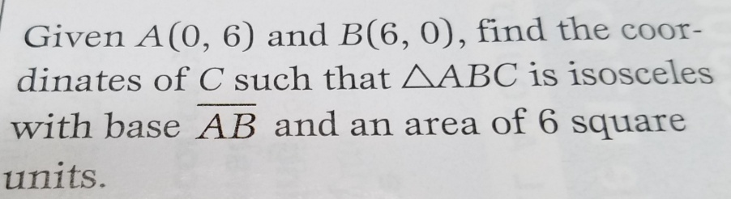
According to Wikipedia, an isosceles triangle is a triangle that has two sides of equal length. The equal sides are called legs and the third side is called the base.

In this problem, you are given two vertices, A and B, of a triangle and are to find the coordinates of the third vertex C, such that the triangle ABC is isosceles with base  and area myArea square units. Since two solutions exist, you will implement two methods. The first method returns the vertex C with the largest x value (if both vertices have the same x value, return the vertex with the larger y value) and the second method returns the vertex with the smallest x value.

This problem uses the completed TriangleCoordinate helper class representing the coordinates of a vertex of a Triangle. The TriangleCoordinate has accessor methods getX() (returns the x-value) and getY() (returns the y-value) and a correctly implemented equals method. getX() and getY() both return double values.

In this problem you will complete two methods in the FunWithTriangles class. Both vertexA and vertexB are TriangleCoordinate objects and are instance variables in the FunWithTriangles class. The instance variables are initialized by the constructor.

Note: all sample data shown in this problem uses whole numbers, the actual test data will include non integer values.

The first method to complete is:
TriangleCoordinate generateAreaWithLargestXcoordinate(double myArea). generateAreaWithLargestXcoordinate returns the TriangleCoordinate such that, along with vertexA and vertexB forms an isosceles triangle with base formed by vertexA and vertexB and area equal to myArea. Since two different triangles (and therefore two different vertices) exist, this method returns the TriangleCoordinate representing the vertex with the largest x coordinate. If the vertex of both triangles has the same x value, return the vertex with the largest y value.

The following shows the results of generateAreaWithLargestXcoordinate method. In this example, the base formed by the given TriangleCoordinate has slope = -1.
The following code | Returns
TriangleCoordinate x = new TriangleCoordinate(6, 0);
TriangleCoordinate y = new TriangleCoordinate(0, 6);

FunWithTriangles fwt = new FunWithTriangles(x, y);

TriangleCoordinate ans =
fwt.generateAreaWithLargestXcoordinate(6);
ans.getX(); | 4.0
ans.getY(); | 4.0

The following shows the results of generateAreaWithLargestXcoordinate method. In this example, the base formed by the given TriangleCoordinate is horizontal (has slope = 0).
The following code | Returns
TriangleCoordinate x = new TriangleCoordinate(-5, 0);
TriangleCoordinate y = new TriangleCoordinate(5, 0);

FunWithTriangles fwt = new FunWithTriangles(x, y);

TriangleCoordinate ans =
fwt.generateAreaWithLargestXcoordinate(35);
ans.getX(); | 0.0
ans.getY(); | 7.0

The following shows the results of generateAreaWithLargestXcoordinate method. In this example, the base formed by the given TriangleCoordinate is vertical (has undefined slope).
The following code | Returns
TriangleCoordinate x = new TriangleCoordinate(5, 3);
TriangleCoordinate y = new TriangleCoordinate(5, 9);

FunWithTriangles fwt = new FunWithTriangles(x, y);

TriangleCoordinate ans =
fwt.generateAreaWithLargestXcoordinate(30);
ans.getX(); | 15
ans.getY(); | 6

The following shows the results of generateAreaWithLargestXcoordinate method. In this example, the base formed by the given TriangleCoordinate has a slope = 3/4.
The following code | Returns
// base with random slope
TriangleCoordinate x = new TriangleCoordinate(-10, 3);
TriangleCoordinate y = new TriangleCoordinate(-2, 9);

FunWithTriangles fwt = new FunWithTriangles(x, y);

TriangleCoordinate ans =
fwt.generateAreaWithLargestXcoordinate(50);
ans.getX(); | 0.0
ans.getY(); | -2.0

The second method to complete is:
TriangleCoordinate generateAreaWithSmallestXcoordinate(double myArea). generateAreaWithSmallestXcoordinate returns the TriangleCoordinate such that, along with vertexA and vertexB forms an isosceles triangle with base formed by vertexA and vertexB and area equal to myArea. Since two different triangles (and therefore two different vertices) exist, this method returns the TriangleCoordinate representing the vertex with the smallest x coordinate. If the vertex of both triangles has the same x value, return the vertex with the smallest y value.

The following shows the results of generateAreaWithSmallestXcoordinate method. In this example, the base formed by the given TriangleCoordinate has slope = -1.
The following code | Returns
TriangleCoordinate x = new TriangleCoordinate(6,0);
TriangleCoordinate y = new TriangleCoordinate(0, 6);

FunWithTriangles fwt = new FunWithTriangles(x, y);

TriangleCoordinate ans
fwt.generateAreaWithSmallestXcoordinate(6);
ans.getX(); | 2.0
ans.getY(); | 2.0

The following shows the results of generateAreaWithSmallestXcoordinate method. In this example, the base formed by the given TriangleCoordinate is horizontal (has slope = 0).
The following code | Returns
TriangleCoordinate x = new TriangleCoordinate(-5,0);
TriangleCoordinate y = new TriangleCoordinate(5, 0);

FunWithTriangles fwt = new FunWithTriangles(x, y);

TriangleCoordinate ans =
fwt.generateAreaWithLargestXcoordinate(6);
ans.getX(); | 0.0
ans.getY(); | -7.0

The following shows the results of generateAreaWithSmallestXcoordinate method. In this example, the base formed by the given TriangleCoordinate is vertical (has undefined slope).
The following code | Returns
TriangleCoordinate x = new TriangleCoordinate(5, 3);
TriangleCoordinate y = new TriangleCoordinate(5, 9);

FunWithTriangles fwt = new FunWithTriangles(x, y);

TriangleCoordinate ans =
fwt.generateAreaWithSmallestXcoordinate(30);
ans.getX(); | -5
ans.getY(); | 6

The following shows the results of generateAreaWithSmallestXcoordinate method. In this example, the base formed by the given TriangleCoordinate has a slope = 3/4.
The following code | Returns
TriangleCoordinate x = new TriangleCoordinate(-10,3);
TriangleCoordinate y = new TriangleCoordinate(-2, 9);

FunWithTriangles fwt = new FunWithTriangles(x, y);

TriangleCoordinate ans =
fwt.generateAreaWithSmallestXcoordinate(50);
ans.getX(); | -12.0
ans.getY(); | 14.0

